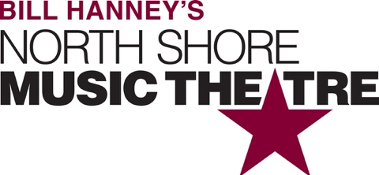

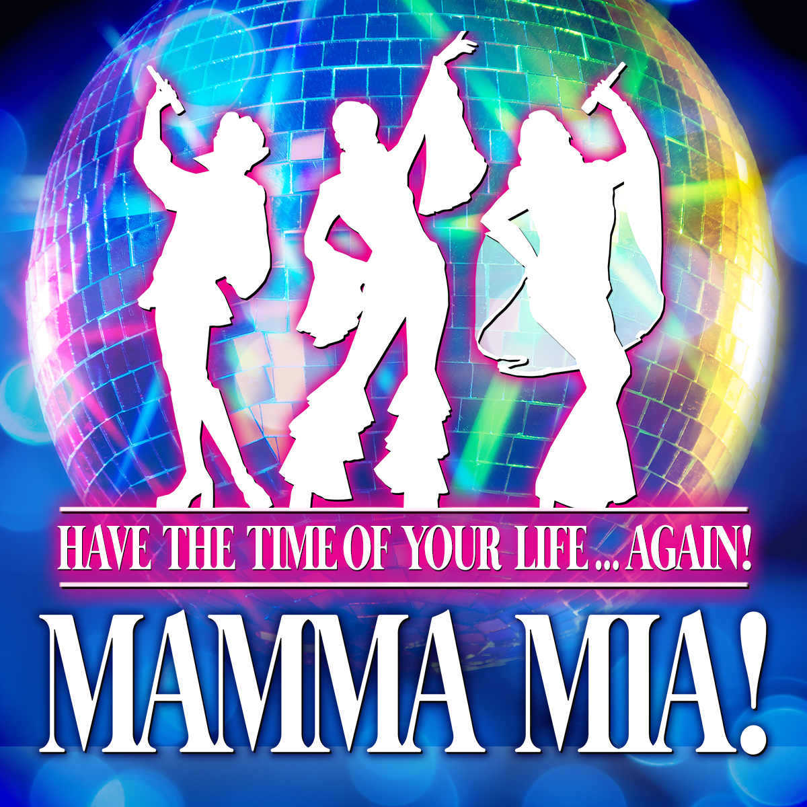

Group Name
Show Date | 00:00 AM/PM
$00.00

Prepare to have the time of your life... AGAIN! Bill Hanney is bringing back MAMMA MIA! for an Encore Performance! MAMMA MIA! is the mega-hit Broadway show about a daughter's dream… a mother’s secret… and a trip down the aisle you’ll never forget! MAMMA MIA! is packed with 22 ABBA hits, including “Dancing Queen,” “Super Trouper,” “Take A Chance on Me,” and “The Winner Takes It All.” This worldwide blockbuster will have you dancing in your seats! RUNNING TIME: 2h 35m (includes intermission).
CONTENT ADVISORY: Teen/Adult audiences. Not appropriate for young audiences/those easily offended by adult humor.

[SPACE RESERVED FOR YOUR GROUP INFO, LOGO & CONTACT]

