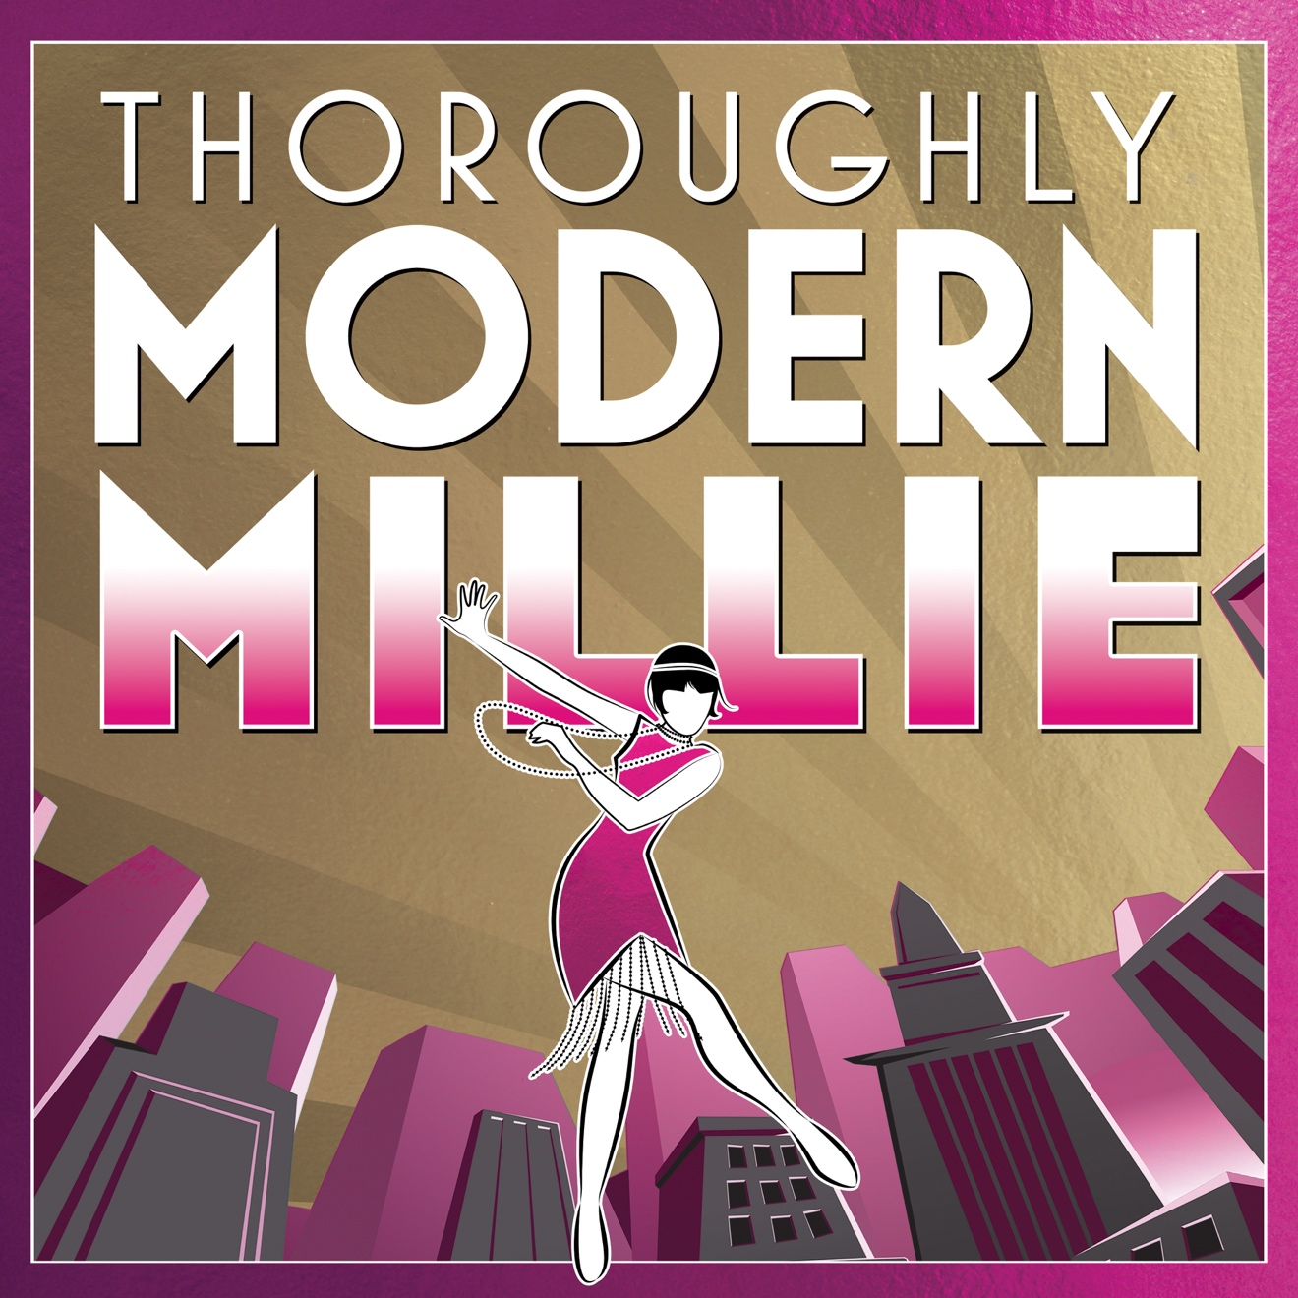

Group Name
Show Date | 00:00 AM/PM
$00.00

Ring in the (new) 20s with THOROUGHLY MODERN MILLIE—filled with flappers, tappers, and a roaring good time. Set in 1922 New York, small-town newcomer Millie jumps headlong into a makeover and a dizzy plan to marry rich—until she falls for a penniless charmer. Her adventures are crowded with a flurry of jazz-age ladies, a runaway heiress, a nefarious landlady, and more. This Tony Award-winning Best Musical is a mix of mistaken identity, high-spirited show tunes, and tap-happy dance numbers that will have more kick than bootleg gin. RUNNING TIME: 2h 25m (includes intermission).

[SPACE RESERVED FOR YOUR GROUP INFO, LOGO & CONTACT]

