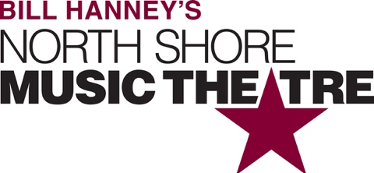

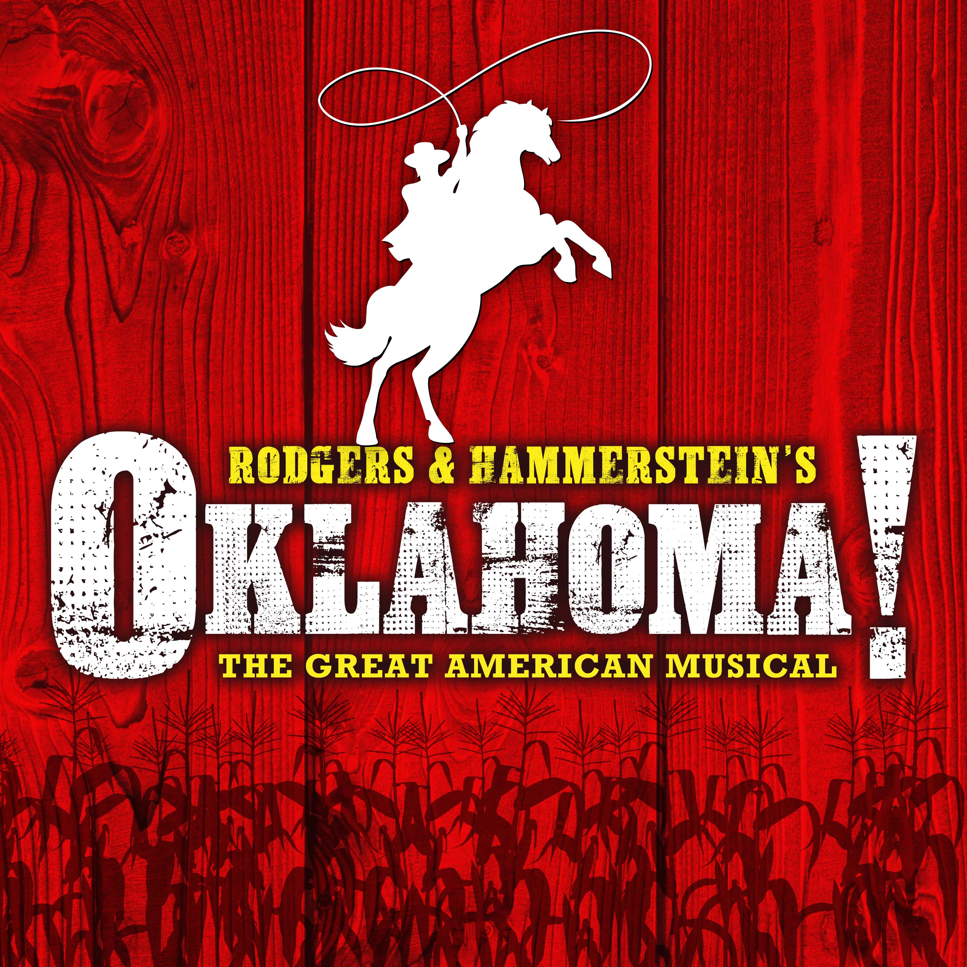

Group Name
Show Date | 00:00 AM/PM
$00.00

One of the greatest American Musicals, Rodgers and Hammerstein’s OKLAHOMA!, returns to North Shore Music Theatre for the first time in more than 25 years! Cowboy Curly and farm girl Laurey are taking their sweet time falling in love. Can these stubborn romantics admit their feelings before it’s too late? Passion, laughter and high-kicking choreography blossom in a land where the wind comes sweepin’ down the plain. RUNNING TIME: Approx. 2h 45m (includes intermission) CONTENT ADVISORY: Suitable for all audiences.

[SPACE RESERVED FOR YOUR GROUP INFO, LOGO & CONTACT]

