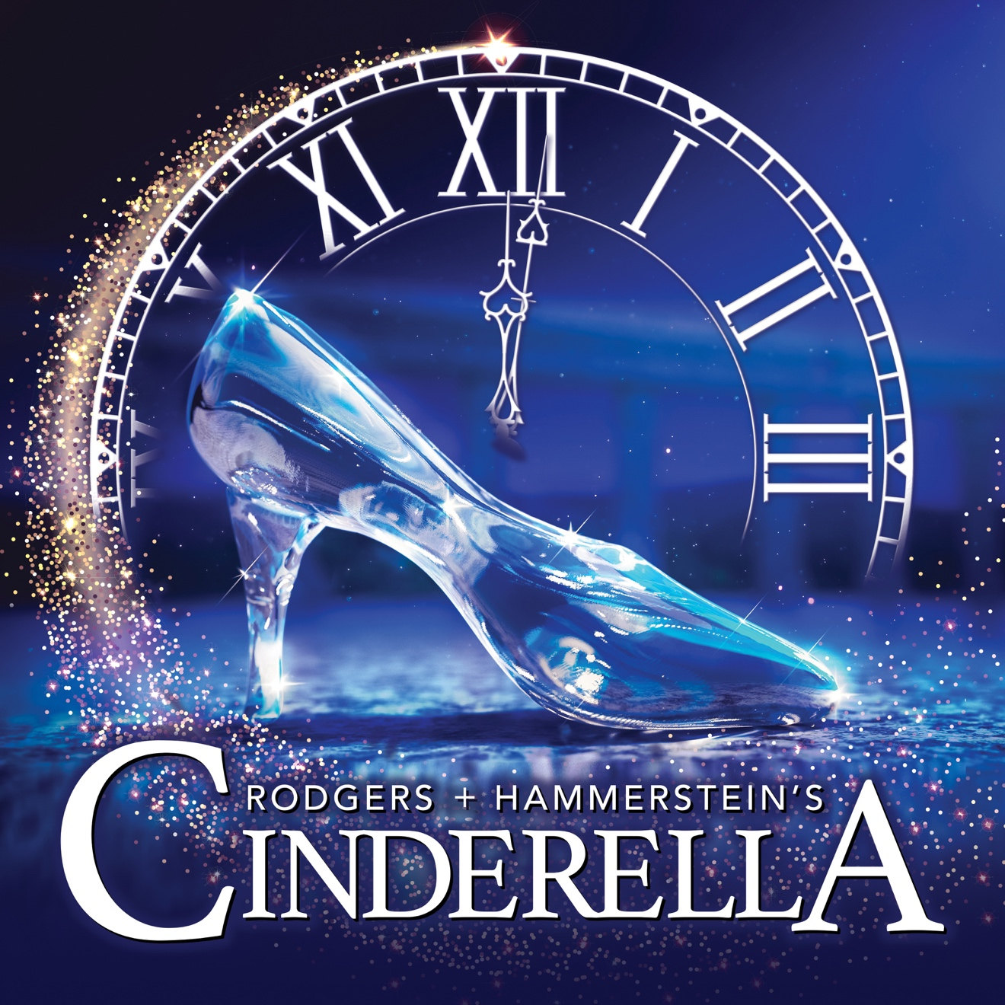

Group Name
Show Date | 00:00 AM/PM
$00.00

Rodgers + Hammerstein’s CINDERELLA is the Tony® Award-winning musical that has delighted generations. Our magical production features an incredible live orchestra, jaw-dropping transformations and all the moments you love: the pumpkin, glass slipper, masked ball and more— plus surprising new twists! Rediscover the beloved songs, including “In My Own Little Corner,” “Impossible,” and “Ten Minutes Ago,” in this hilarious and romantic experience for anyone who’s ever had a dream. RUNNING TIME: 2h 20m (includes intermission). CONTENT ADVISORY: Appropriate for all audiences with children age 6–10.

[SPACE RESERVED FOR YOUR GROUP INFO, LOGO & CONTACT]

