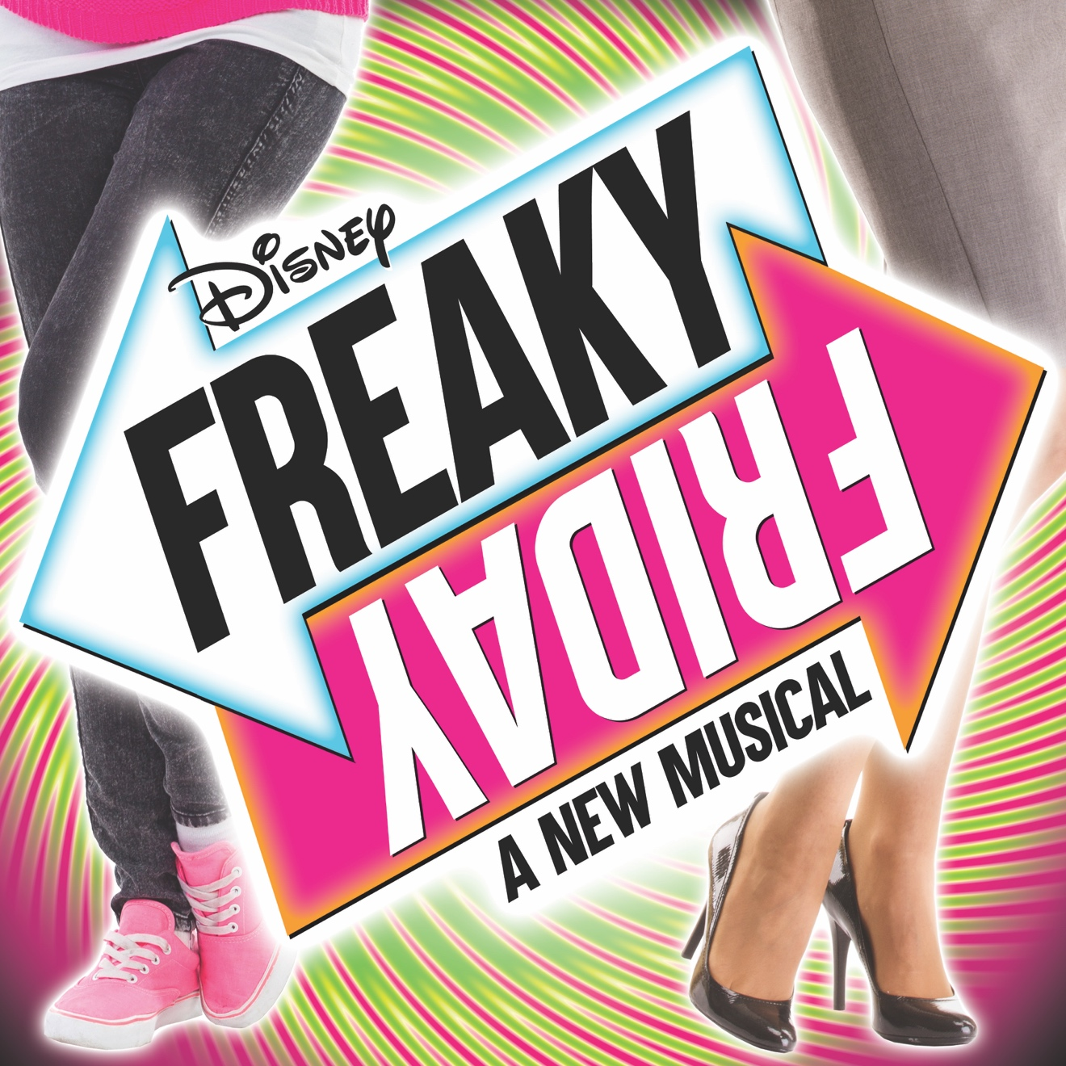

Group Name
Show Date | 00:00 AM/PM
$00.00

FREAKY FRIDAY is Disney’s new body-swap musical comedy about an overworked mother and teenage daughter who magically spend a day in each other's shoes. Katherine and Ellie face a variety of challenges trying to get through the day as each other and ultimately learn a lot about what life is really like on the other side of the generation gap. RUNNING TIME: Approx. 2h 20m (includes intermission)
CONTENT ADVISORY: Suitable for all audiences.

[SPACE RESERVED FOR YOUR GROUP INFO, LOGO & CONTACT]

