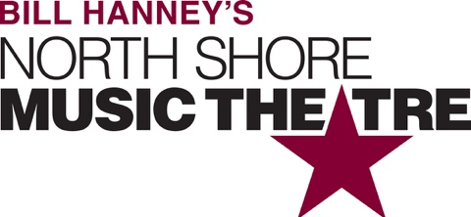

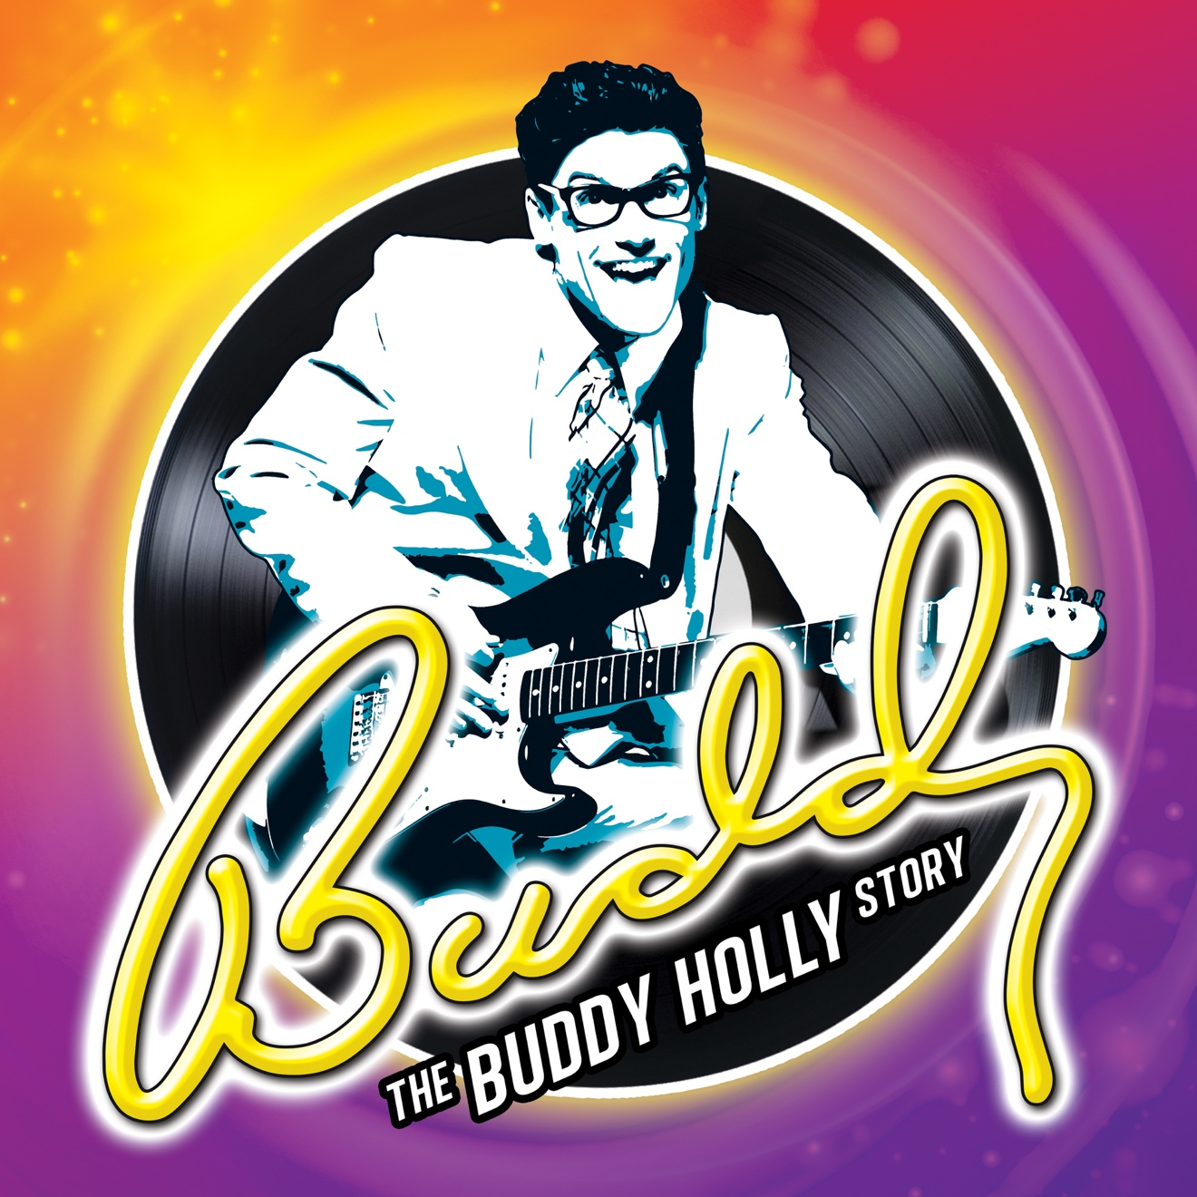

Group Name
Show Date | 00:00 AM/PM
$00.00

Follow the incredible journey of Buddy Holly’s meteoric rise to the top of the record charts during the golden days of rock ‘n’ roll in this dynamic tribute musical featuring such rousing 50s favorites as “Peggy Sue,” “Oh Boy,” “Maybe Baby,” and more! BUDDY: THE BUDDY HOLLY STORY is a joyous celebration of a musical legend, has audiences on their feet in every corner of the globe and will explode on the NSMT stage in a toe-tapping, hand-clapping extravaganza! RUNNING TIME: 2h 20m (includes intermission). CONTENT ADVISORY: suitable for all ages.

[SPACE RESERVED FOR YOUR GROUP INFO, LOGO & CONTACT]

