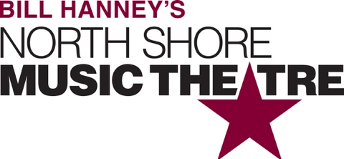

Group Name
Show Date | 00:00 AM/PM
$00.00

Get ready for the Tony-Award winning JERSEY BOYS at NSMT! They were just four guys from Jersey, until they sang their very first note. They had a sound nobody had ever heard... and the radio just couldn’t get enough of. But while their harmonies were perfect on stage, off-stage was a very different story—a story that has made them an international sensation all over again. RUNNING TIME: Approx. 2h 35m (includes intermission) CONTENT ADVISORY: Contains authentic, “profane Jersey language” and is recommended for ages 12+.

[SPACE RESERVED FOR YOUR GROUP INFO, LOGO & CONTACT]

