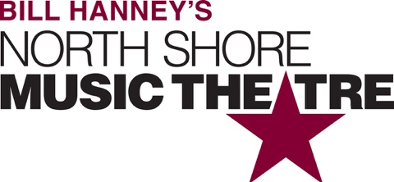

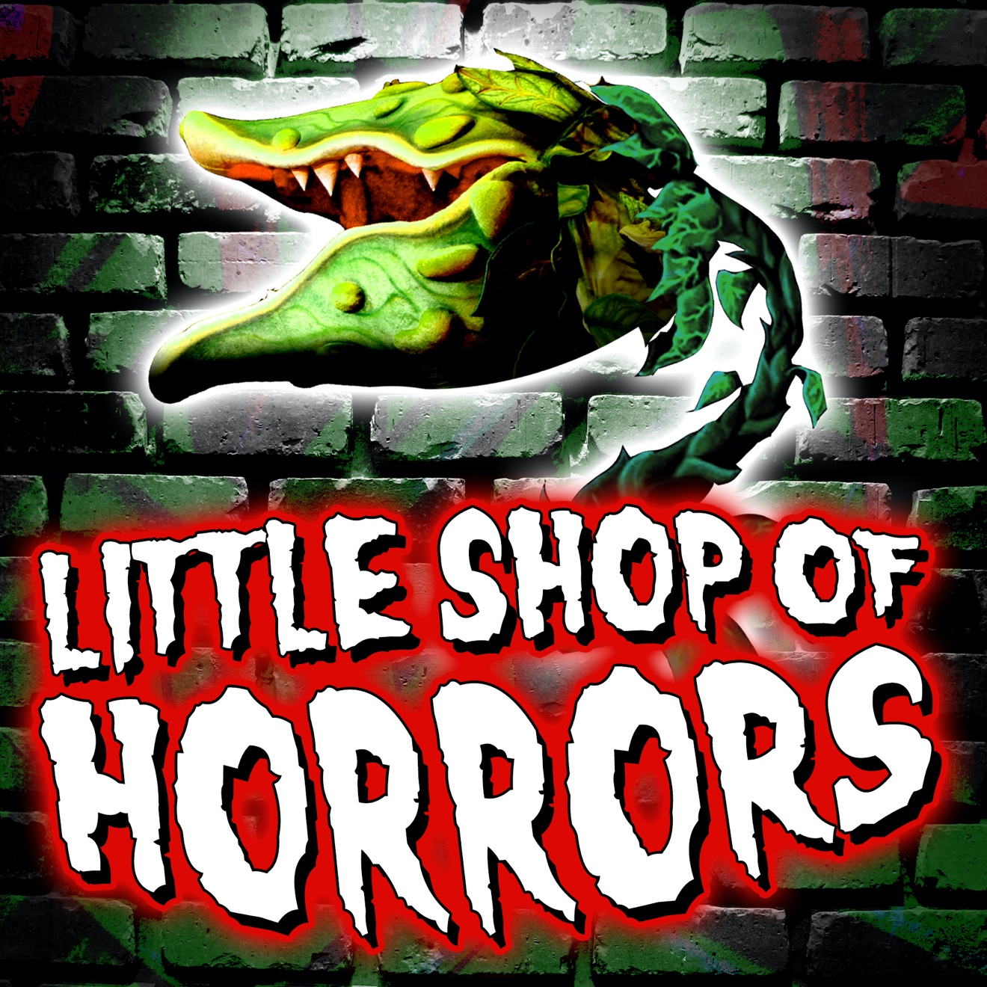

Group Name
Show Date | 00:00 AM/PM
$00.00

Just in time for fall, NSMT will unleash the hysterically campy and delightfully dark modern classic LITTLE SHOP OF HORRORS on the unsuspecting public. This deviously delicious Broadway and Hollywood sci-fi smash musical with music/lyrics by the creative geniuses of Disney’s Little Mermaid, Beauty & the Beast, and Aladdin has devoured the hearts of theatre goers for decades. The story follows hapless floral assistant Seymour Krelborn, his coworker-crush Audrey, and a carnivorous plant with some devilish intents. RUNNING TIME: 2h 20m (includes intermission). CONTENT ADVISORY: suitable for audience 8+, features possibly ‘scary’ plant.

[SPACE RESERVED FOR YOUR GROUP INFO, LOGO & CONTACT]

