

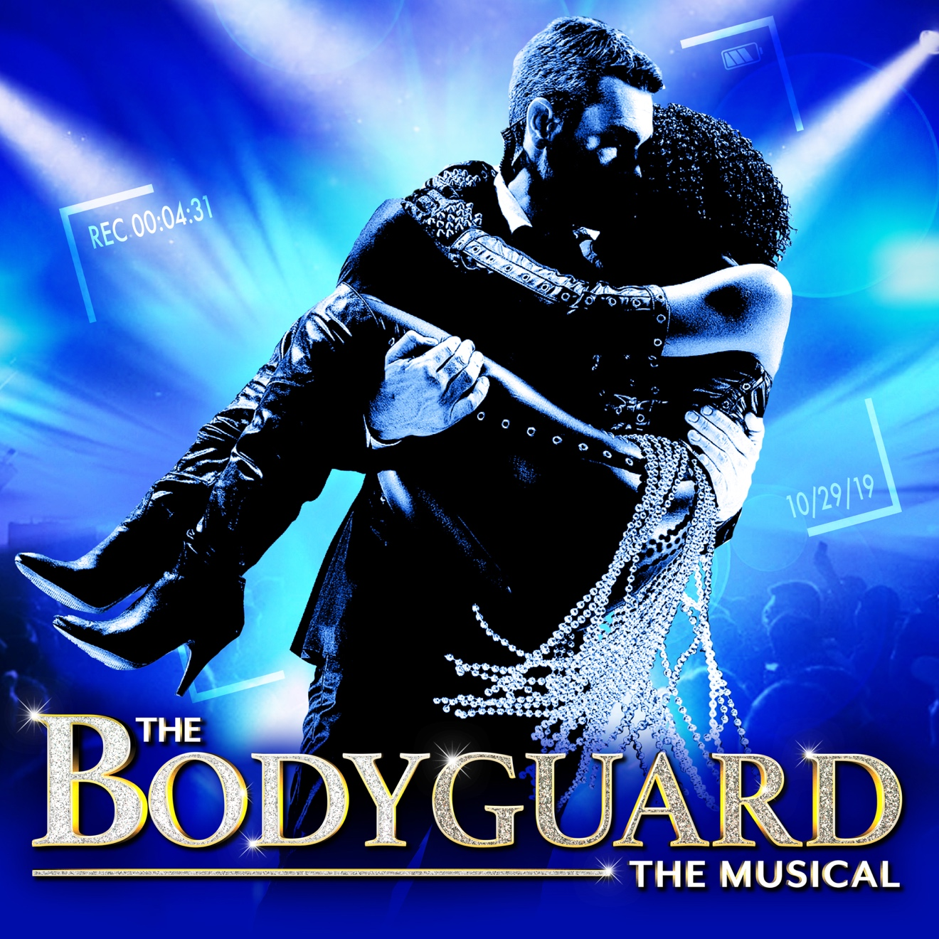

Group Name
Show Date | 00:00 AM/PM
$00.00

THE BODYGUARD is a new musical based on the smash-hit 1992 film! Former Secret Service agent, Frank Farmer, is hired to protect superstar Rachel Marron from an unknown stalker. Each expects to be in charge; what they don’t expect is to fall in love. A romantic thriller, THE BODYGUARD features Whitney Houston classics including Queen of the Night, So Emotional, One Moment in Time, Saving All My Love, Run to You, I Have Nothing, I Wanna Dance with Somebody and I Will Always Love You. RUNNING TIME: 2h 35m (includes intermission) CONTENT ADVISORY: Contains strong language/adult themes. Suitable for teens/adults.

[SPACE RESERVED FOR YOUR GROUP INFO, LOGO & CONTACT]

