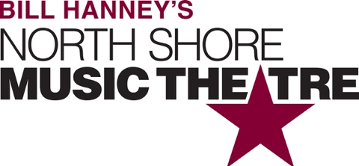

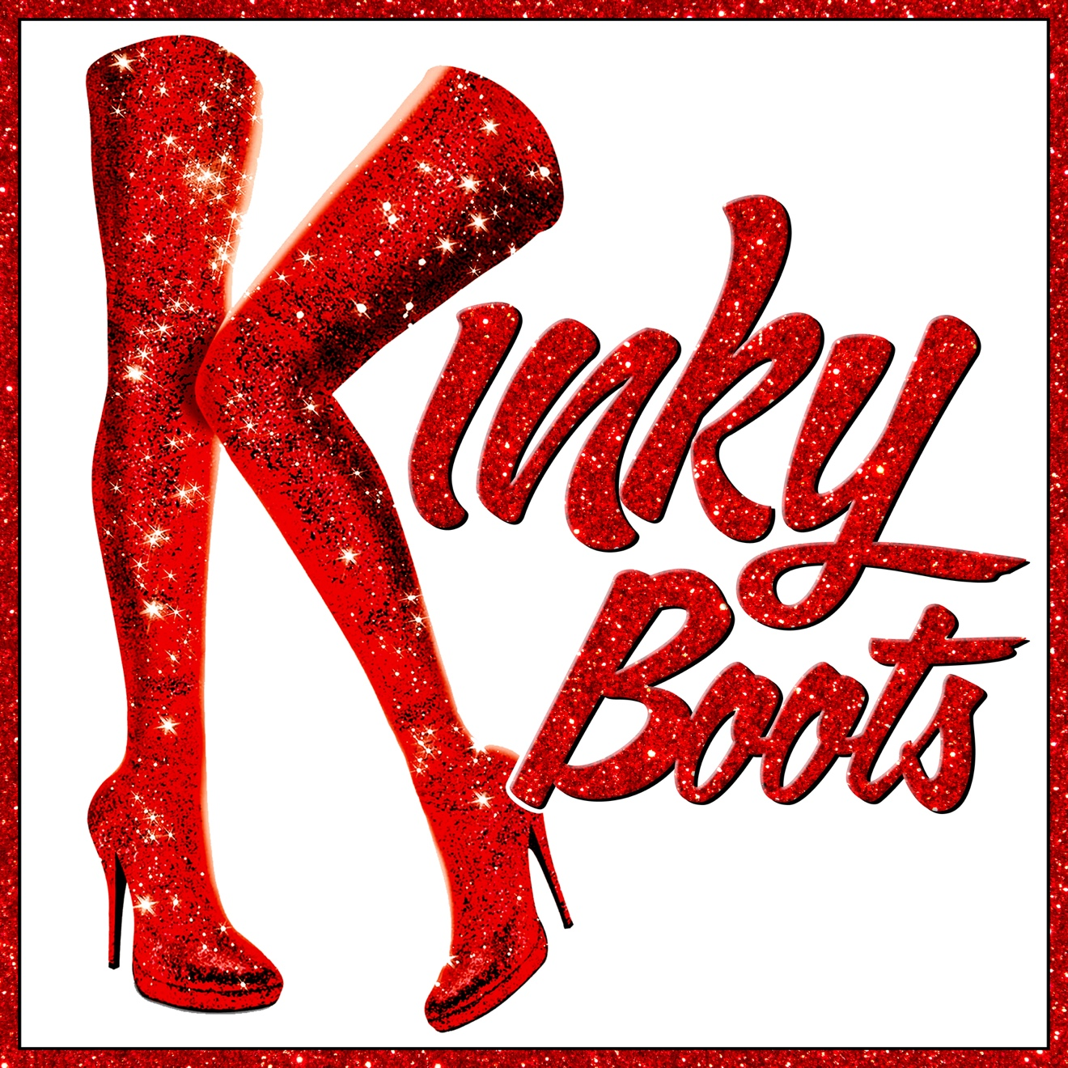

Group Name
Show Date | 00:00 AM/PM
$00.00

KINKY BOOTS is the freshest, most fabulous, feel-good musical and the winner of every major award, including the Tony Award® for Best Musical! With songs by Grammy® and Tony® Award-winning pop icon Cyndi Lauper, this dazzling, sassy and uplifting musical celebrates a joyous story, inspired by true life events, taking you from the factory floor of a men’s shoe factory to the glamorous catwalks of Milan! It’s the ultimate fun night out for everyone to experience the energy, joy and laughter of this dazzling show. RUNNING TIME: 2h 20m (includes intermission). CONTENT ADVISORY: suitable for audiences age 10+.

[SPACE RESERVED FOR YOUR GROUP INFO, LOGO & CONTACT]

