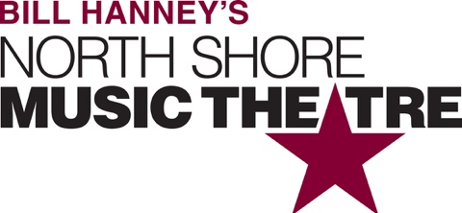

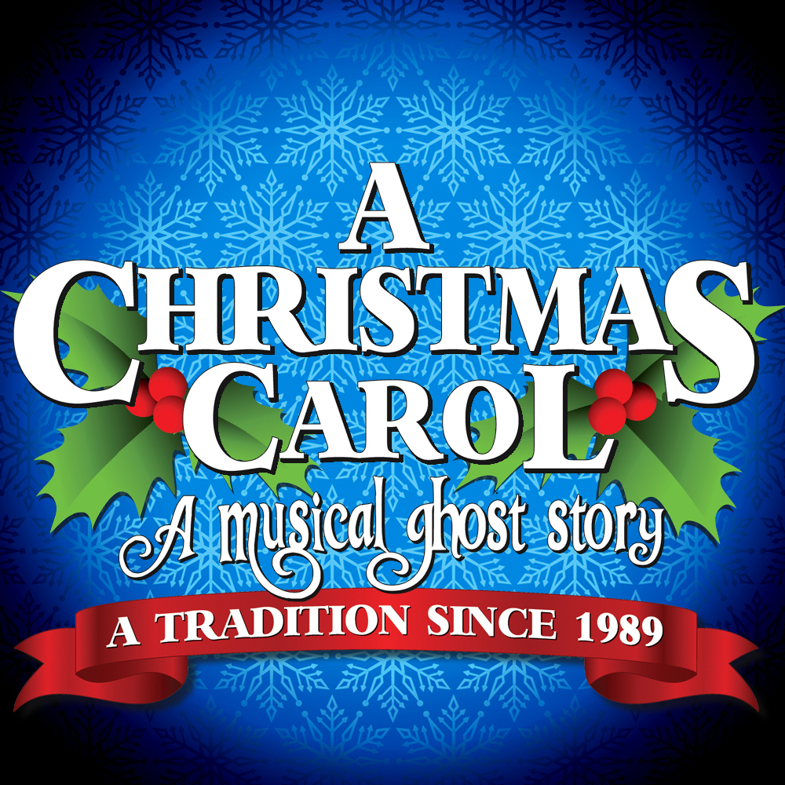

Group Name
Show Date | 00:00 AM/PM
$00.00

New England’s brightest holiday tradition! An original adaptation based on Charles Dickens’ classic novella, A CHRISTMAS CAROL is a musical ghost story following Ebenezer Scrooge through a series of strange and magical journeys where he discovers the true spirit of the holiday season. Featuring dazzling special effects and traditional songs this award-winning production was created specifically for NSMT and has been seen by more than 1 million people since its 1989 debut. RUNNING TIME: 2h 20m (includes intermission) CONTENT ADVISORY: Contains sudden loud noises, pyrotechnics, dark images. May not be suitable for all audiences.

[SPACE RESERVED FOR YOUR GROUP INFO, LOGO & CONTACT]

