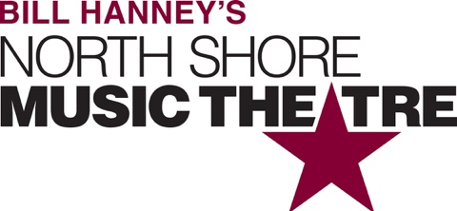

Group Name
Show Date | 00:00 AM/PM
$00.00

New England’s brightest holiday tradition celebrates its 30th annual production! An original adaptation based on the Charles Dickens’ classic, A CHRISTMAS CAROL is NSMT’s original musical ghost story following the miserly Ebenezer Scrooge through a series of strange and magical journeys, where he ultimately discovers the true spirit of the holiday season. Featuring dazzling special effects and traditional songs, this award-winning production has been seen by 1,000,000+ people since1989. RUNNING TIME: 2h 20m (includes intermission). CONTENT ADVISORY: sudden loud noises, pyrotechnics, dark images. May not be suitable for all audiences.

[SPACE RESERVED FOR YOUR GROUP INFO, LOGO & CONTACT]

