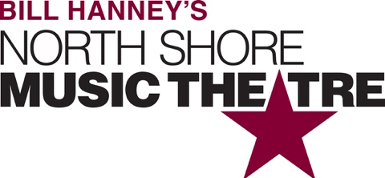

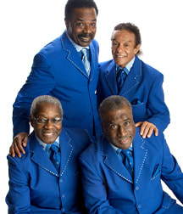
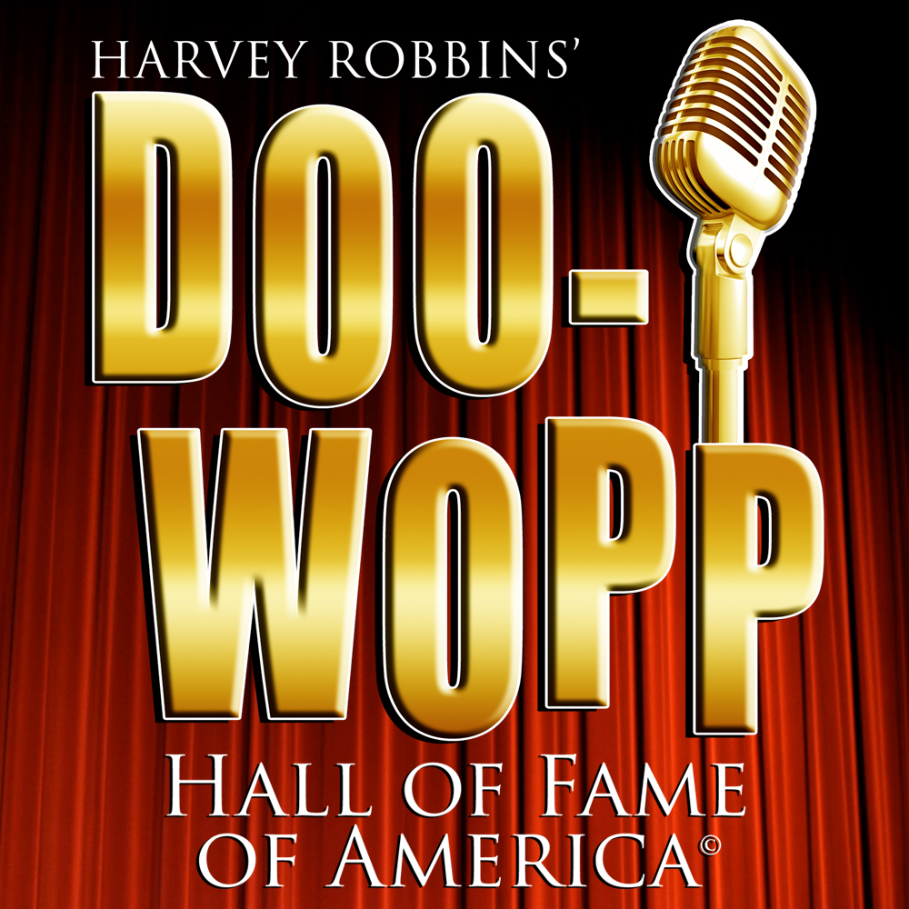

Group Name
Sunday, October 13 | 2:00 PM
$00.00

Featuring: Doo-Wopp Hall of Famer SHIRLEY REEVES original lead singer of The Shirelles: “Will You Still Love Me Tomorrow”, “Soldier Boy”, “Mama Said”, “Tonight’s The Night”, “Foolish Little Girl”, “I Met Him On A Sunday”, “Dedicated To The One I Love”; THE MARCELS “Blue Moon” “Heartaches”; also featuring a salute to THE MARVELETTES with LONNIE CLARK & Group: “Please Mr. Postman”, “Don’t Mess With Bill”, “Too Many Fish in The Sea”. (More artists and inductees to be announced!)

[SPACE RESERVED FOR YOUR GROUP INFO, LOGO & CONTACT]

