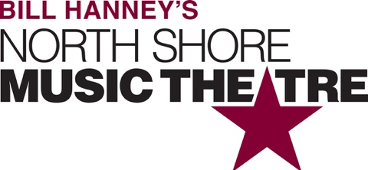

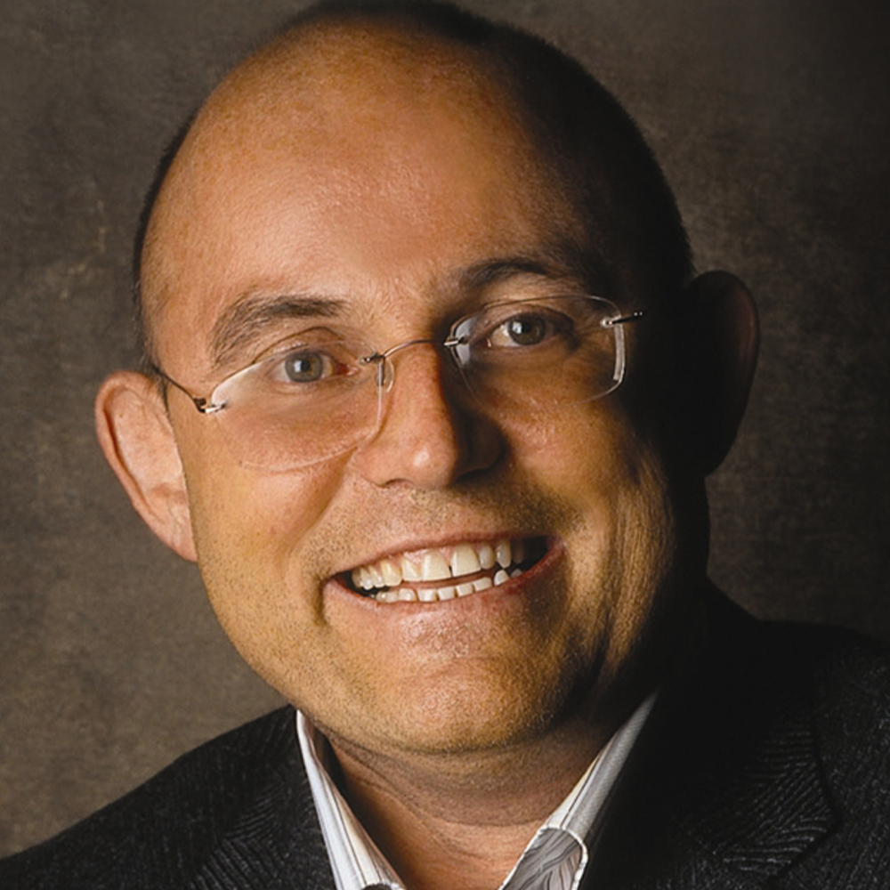

Group Name
Saturday, May 18 | 7:30 PM
$00.00

North Shore Elder Services presents Ronan Tynan is truly a modern day "Renaissance Man." Introduced to international audiences as a member of the Irish Tenors, Tynan quickly became known for his unique voice and irresistible appeal. Dr. Tynan has performed for four U.S. Presidents including President George H.W. Bush and President George W. Bush, as single soloist at the Funeral of President Ronald Reagan, and for President Clinton. As well, Dr. Tynan has sung for two Popes, Pope John Paul II at St. Peter’s Basilica and Pope Benedict at the Concert of Hope. Ronan Tynan’s concerts feature selections from traditional, Irish, religious, and classical venues, this is a concert you don't want to miss!

[SPACE RESERVED FOR YOUR GROUP INFO, LOGO & CONTACT]

