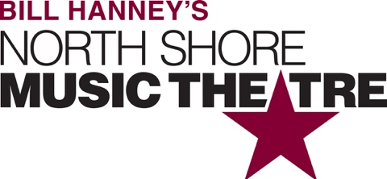

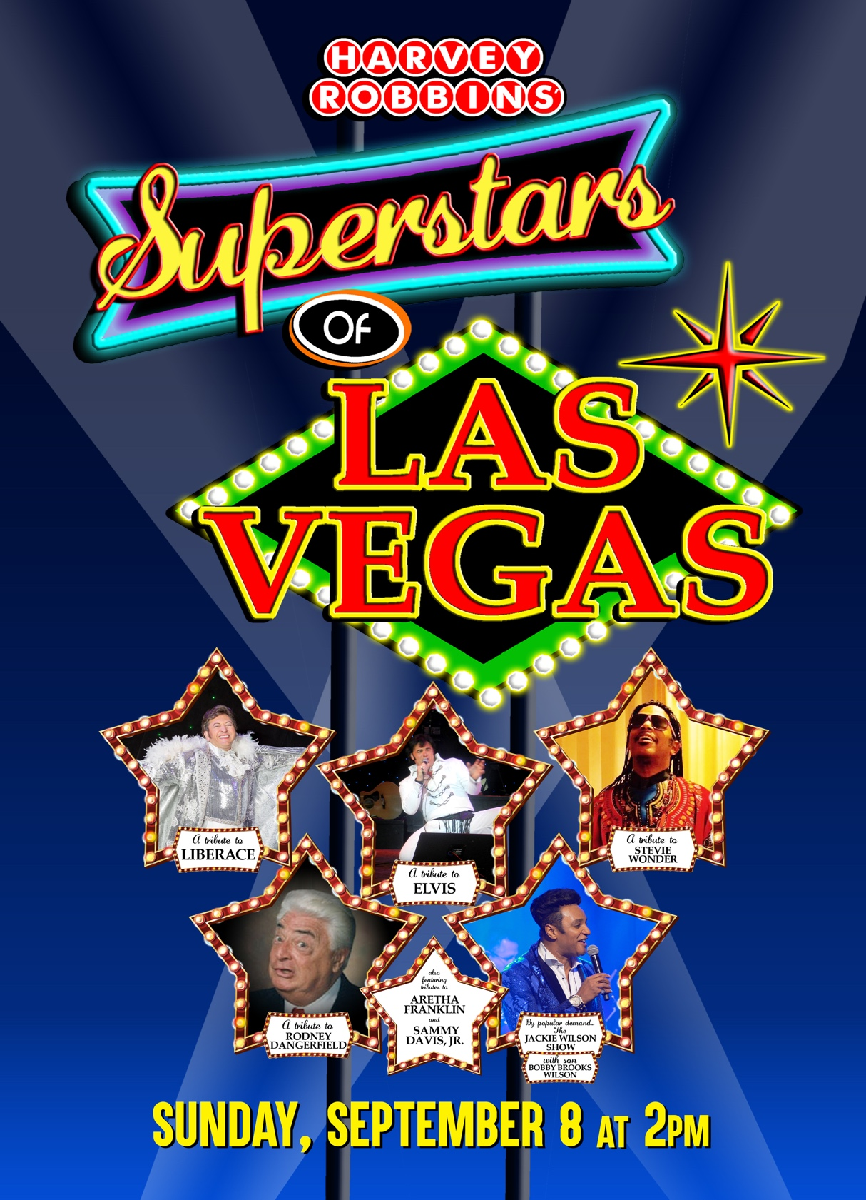

Group Name
Sunday, September 8 | 2:00 PM
$00.00

Harvey Robbins presents SUPERSTARS OF LAS VEGAS, the ultimate tribute concert!

[SPACE RESERVED FOR YOUR GROUP INFO, LOGO & CONTACT]

