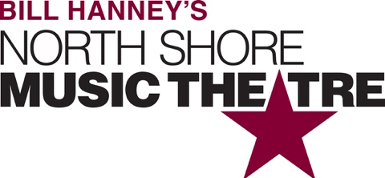

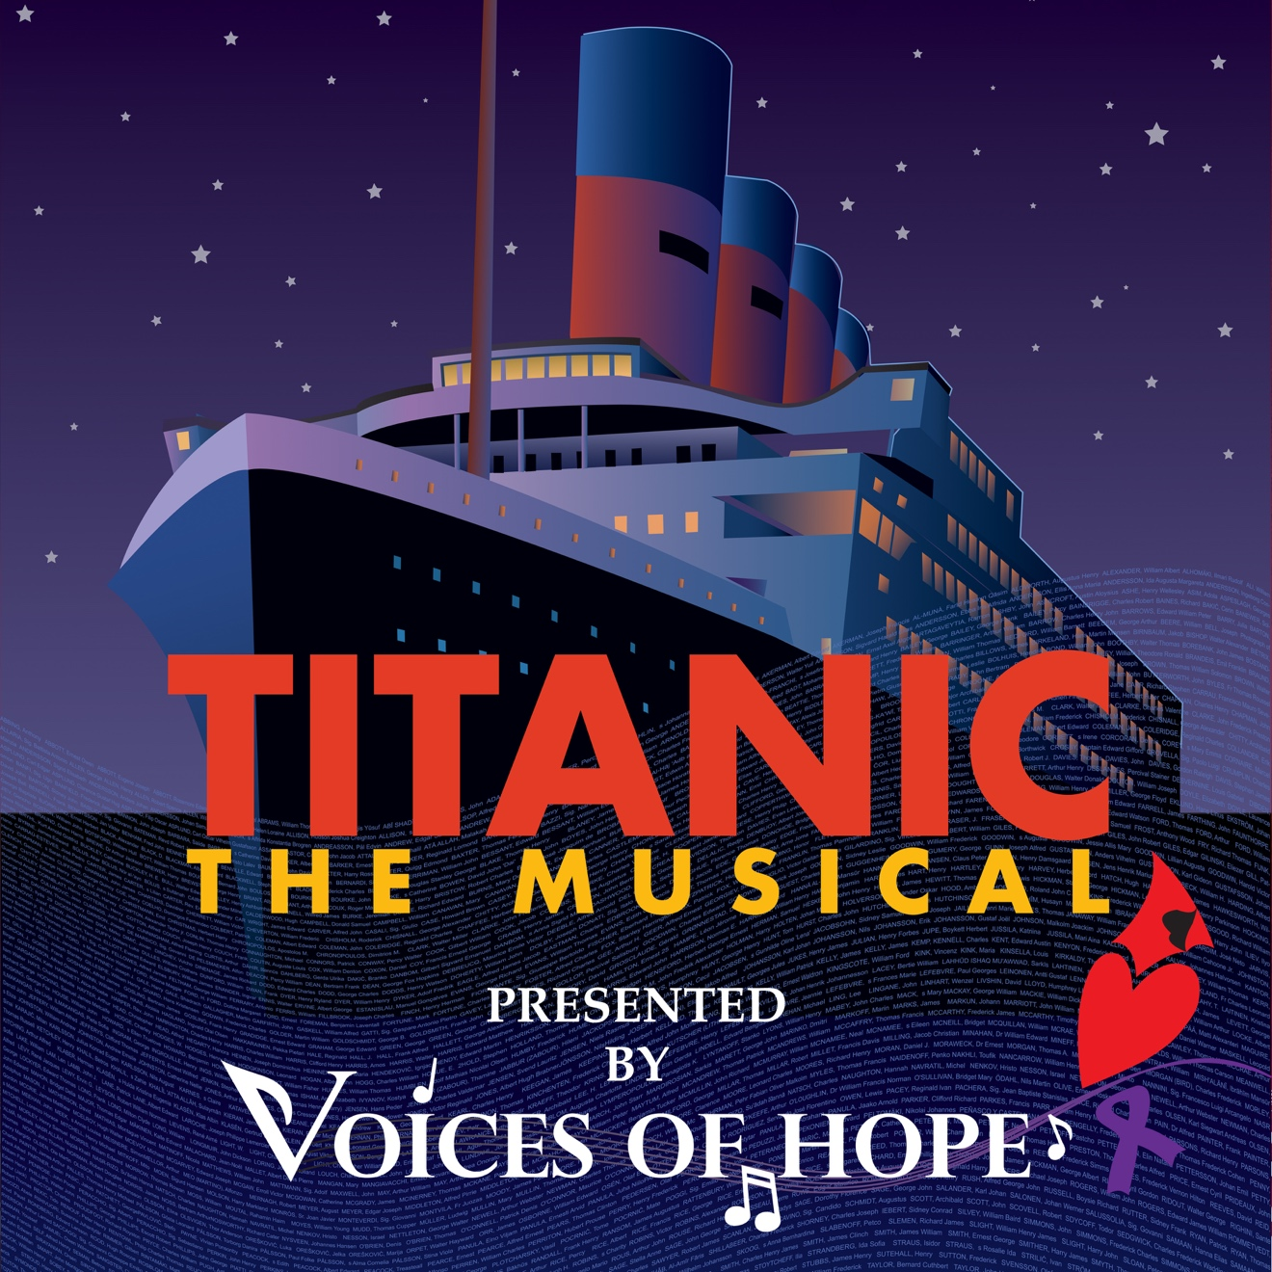

Group Name
Show Date | 0:00 AM/PM
$00.00

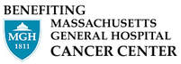
TITANIC THE MUSICAL is presented by Voices of Hope and benefits Termeer Center for Targeted Therapies at the MGH Cancer Center. This Spring, Voices of Hope invites you on board their production of the Tony Award-Winning Best Musical, TITANIC which sails onto the stage at North Shore Music Theatre for the first time. With a lush and stunning musical score and fascinating real-life stories of her passengers, TITANIC is a captivating experience for lovers of both history and musical theater, as it explores the conditions, causes, and indomitable human spirit of the legendary “ship of dreams”.

[SPACE RESERVED FOR YOUR GROUP INFO, LOGO & CONTACT]

